Game of Pig

Requirements:

* Game ends when humanbank > 100 or when computerbank >100
* Ask user if they want to play
* When player rolls a 1, round over and score == 0 for that round
* Loop that switches between user and computer turn
* Ask user if they want to roll or hold at the end of every roll
* Computer intelligence for playing risky or chasing
* At the end of the game, ask user if they want to play again

Firstly, I want to change the symbols for the dice as I do not like those and don’t understand them. (using symbols from <http://xahlee.info/comp/unicode_games_cards.html>)

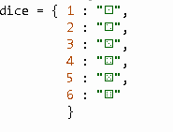

I then added the game's instructions under the welcome screen so that the user understands how to play and what to do.

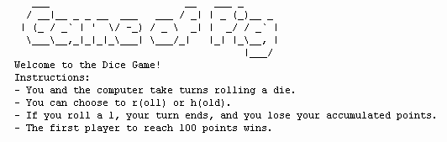

Ask the user if they want to play: I changed the play to assume it's false at the start of the code so that it doesn’t start if the user inputs a random letter, and that it will only start with Y or y.

Flowchart:

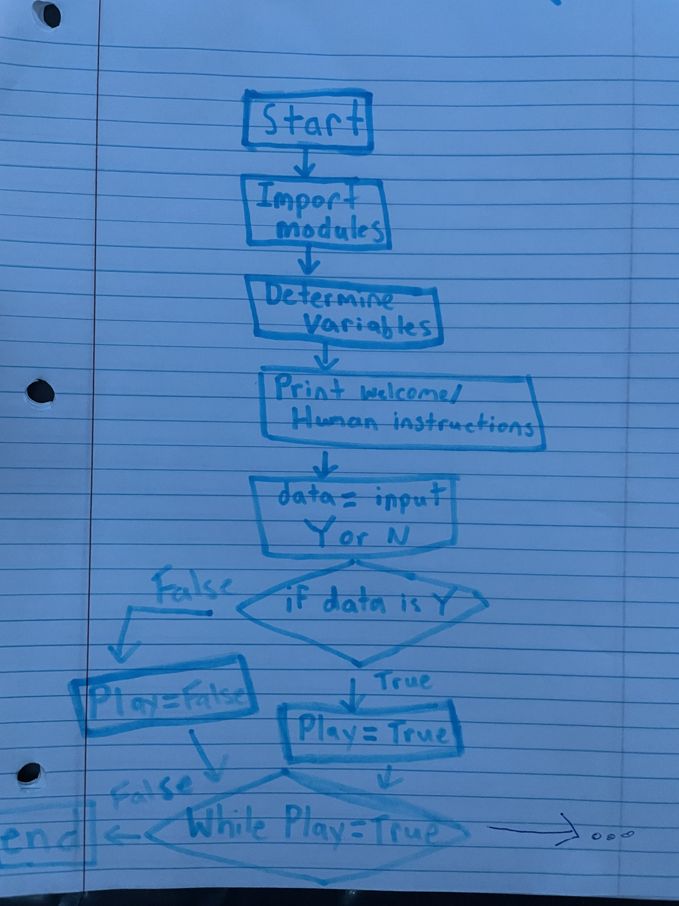

In python:

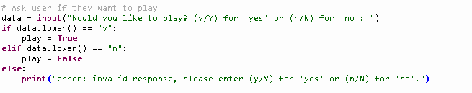

When I try to run the code, the first problem I encounter is that when I input my answer for roll or hold it just keeps rolling until it hits a one on the dice. It does this because the loop states that when the answer is equal to r it keeps rolling the die over and over to fix this, I'm going to use a while True. These are the changes I made:

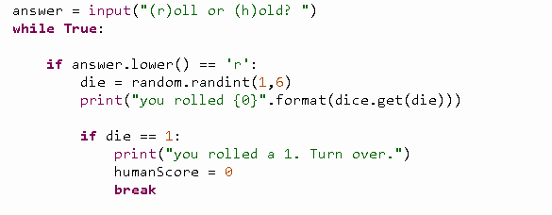

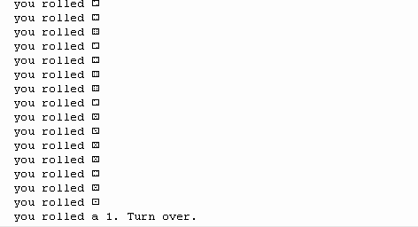

However, it was still giving me the problem where it would keep rolling an infinite amount of times until it hit a 1. I fixed this by moving the answer input into the while true loop and I added a current score counter after every roll by adding a humanScore += die for each die roll and I added an update to the human bank and where it will show the current score of the player and to check if the player has won. Updated flowchart and code:

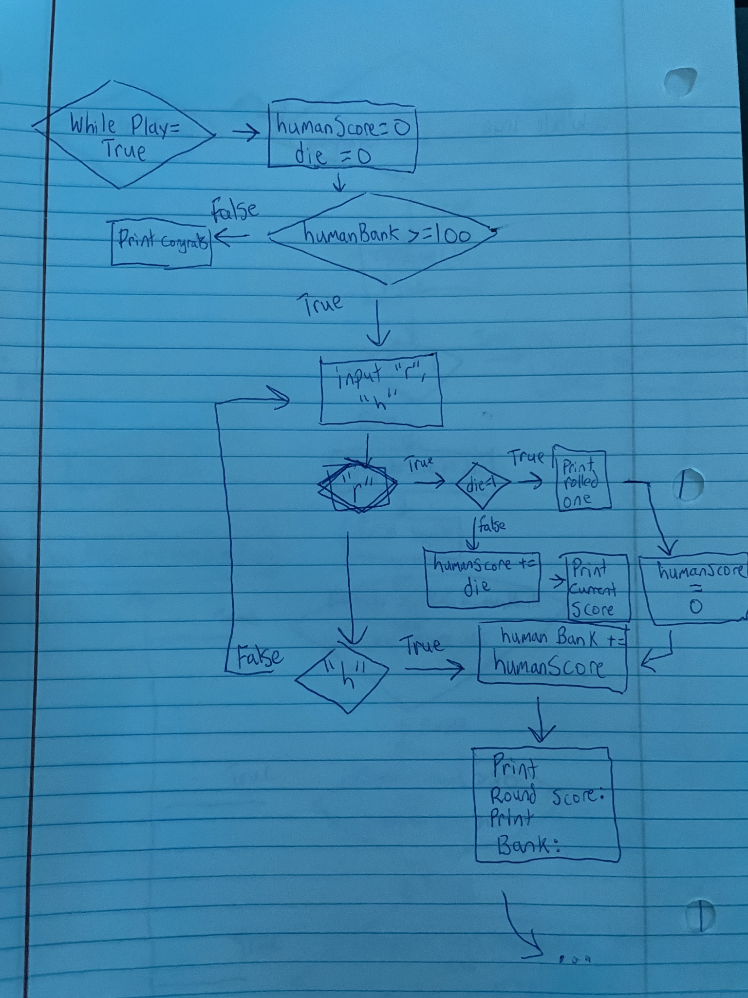

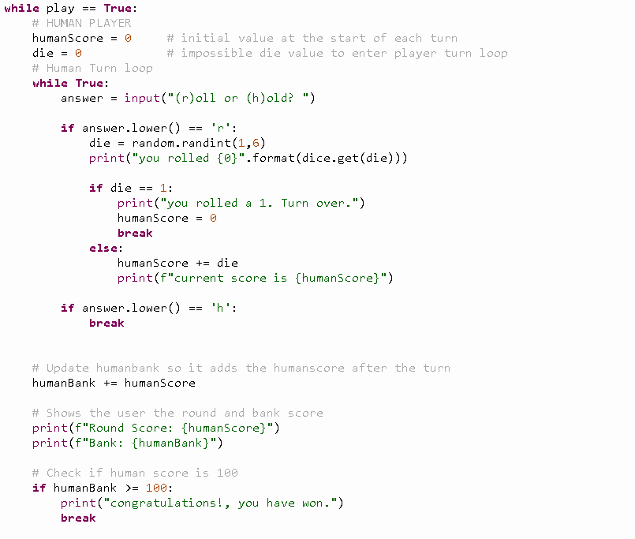

After these changes, the player turn is working as intended in my testing and now it's time to work on the computer's turn and give it some strategy. I used most of the code that I used for the player turn and implemented it into my computer turn code. I made a strategy for the computer to see if the computer is behind it will only hold if it’s at more than 15 and if the computer is ahead it will play conservatively and hold when it gets more than 6. Another strategy for if the bank is above 80, it will play a little riskier and hold if it gets more than 10..

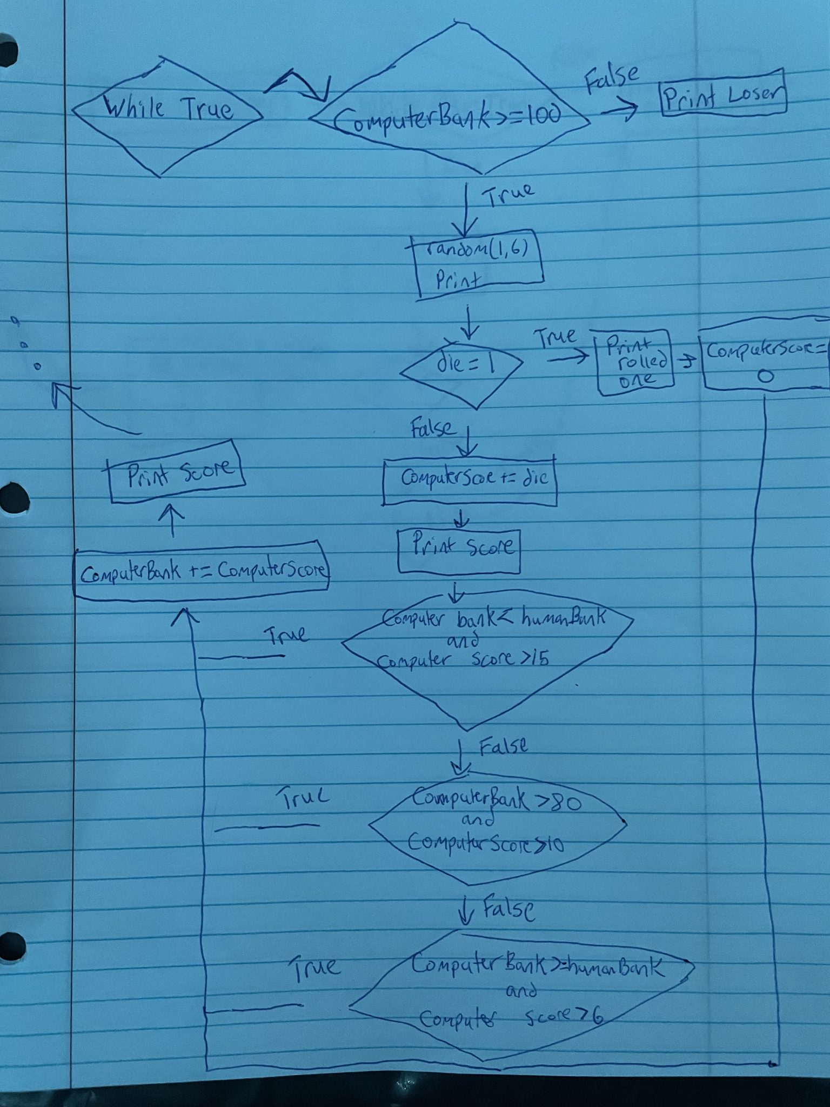]

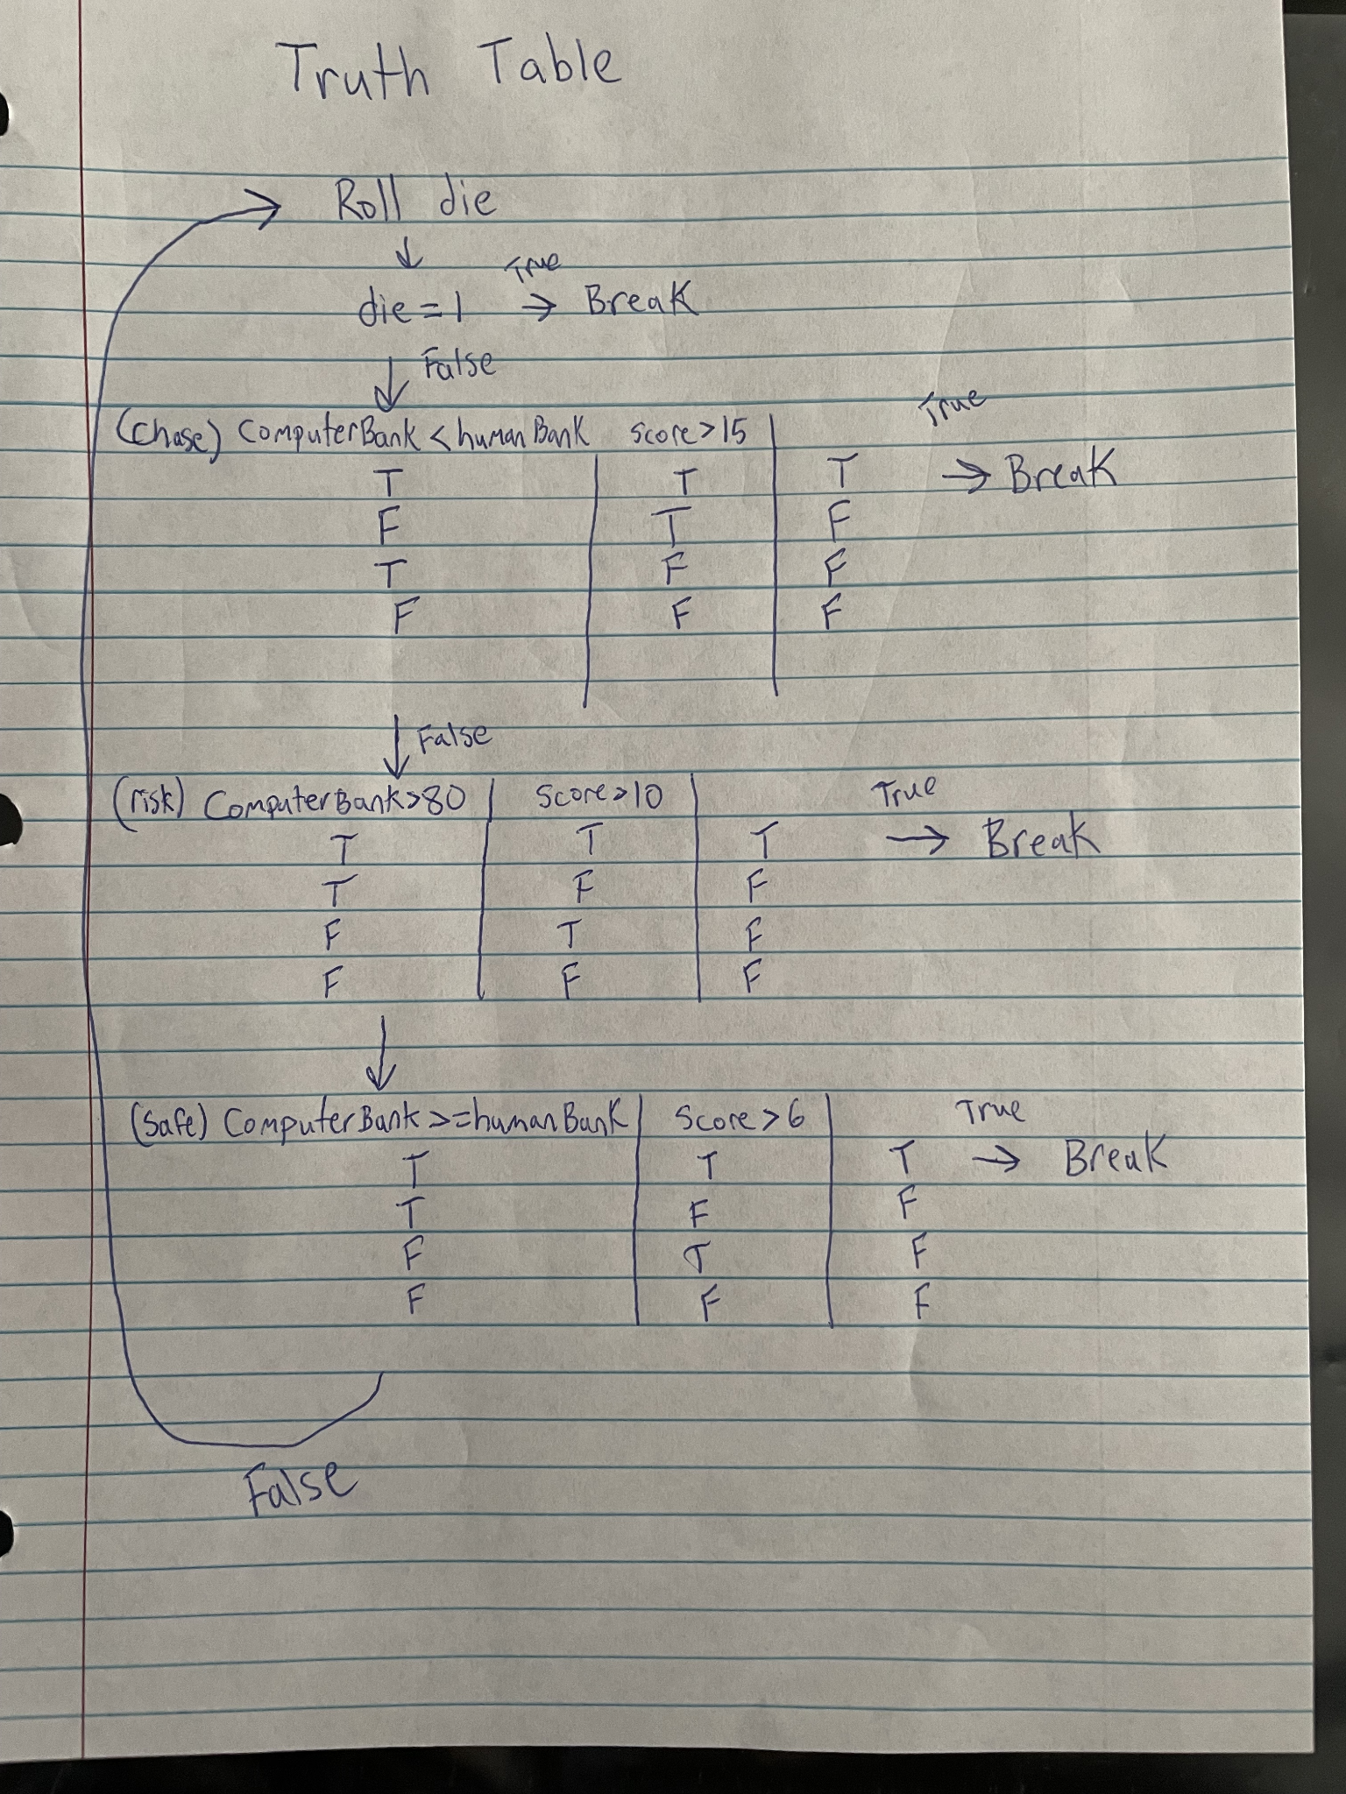

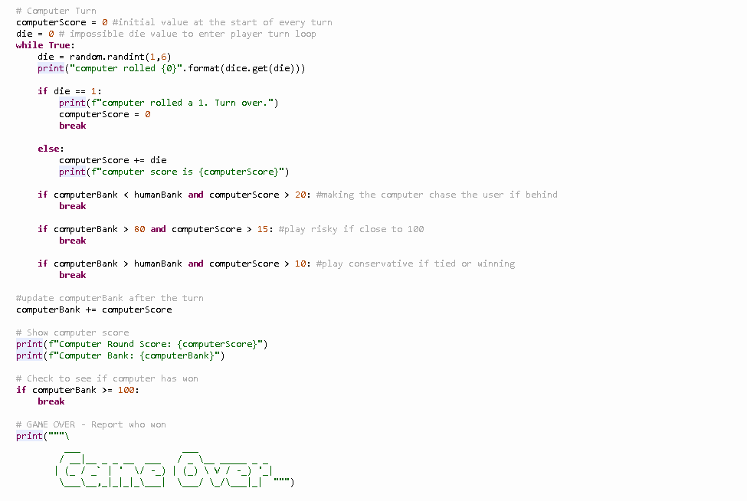

It seems to be working as I intended it to, however, every time it switches back to the user's turn it prints the game over and we do not want that. So, I had to take away the indent on where it shows to print it and now it doesn’t print it every time it switches turns. I also noticed if the computerbank and humanbank had the same value, it would break the game, so I edited the code and made it so if counterbank was equal to or more than humanbank it would hold when it had more than a 6 score. I am going to add the print for who won and ask the user if they want to play again.

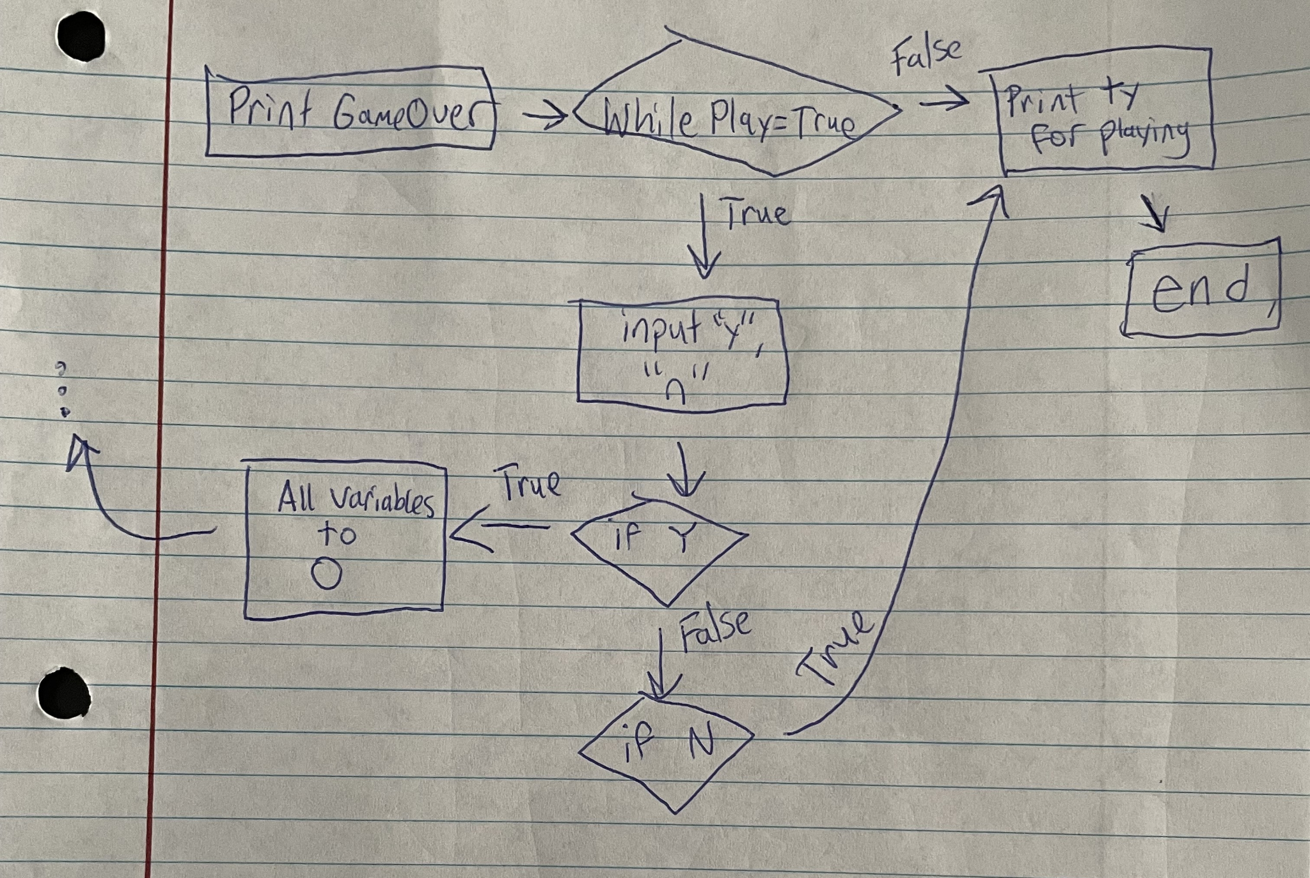

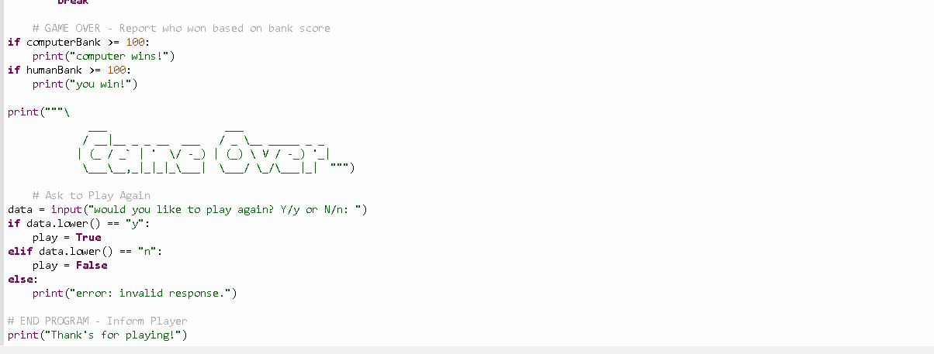

Everything is working fine, except for when it asks the user if they would like to play again, it is just ending no matter what I put for my answer. I suspect this is because I used the same data variable I used for asking the user if they wanted to play in the first place so I am going to try a new variable and see if it works out. This didn’t fix the issue, however, I found the problem. I need to add an outer loop so that the game can start over again when they respond with yes for playing again and also set all the variables back to 0. I added another while loop so that it can continue back to the start:

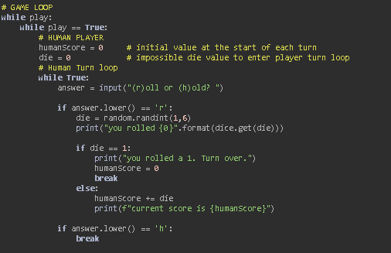

Conclusion: After fixing my outer loop, everything seems to be running perfectly and I haven’t found any flaws in the game. I am very glad I got to experience this project as I feel like I learned a lot during the development of this game and I had a lot of fun working on it and figuring out my mistakes and flaws. I feel like I got the hang of using loops, especially within each other, and how they interact with each other to cause certain situations. It also helped me a lot in understanding how flowcharts work and how to make my own and then create the code off of the flowchart to help my understanding.